6TH Grade Math Supporting Standard Items yet to be tested as of 2019
6.5C - 1 (S) Eighty two Z

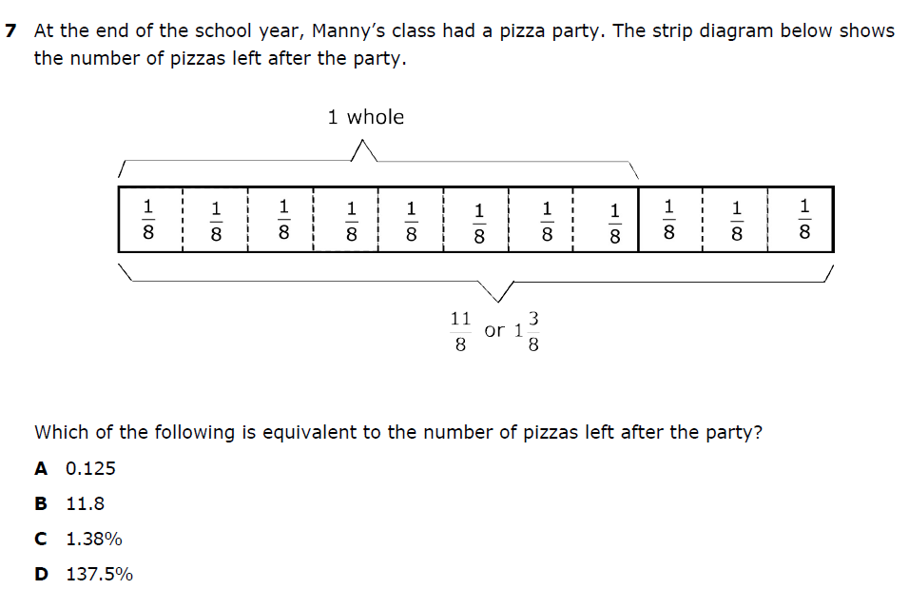

6.5C - 1 (S) Eighty three X
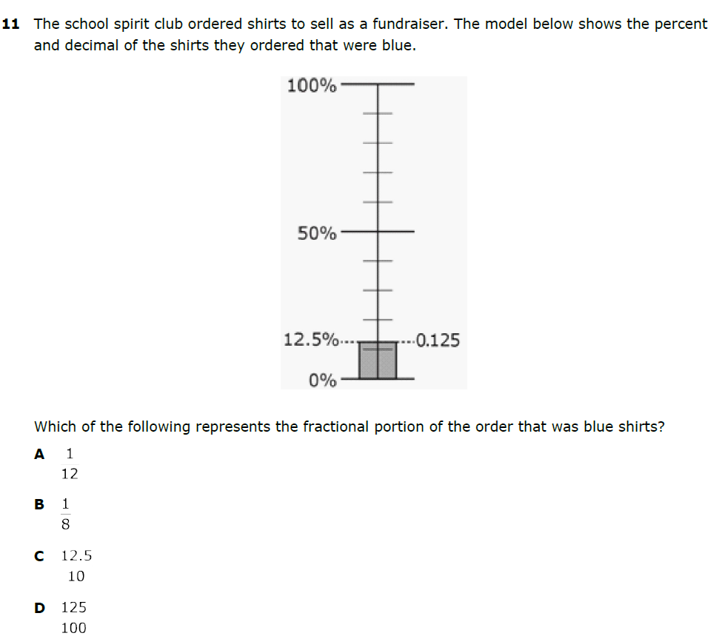
6.7B – 1 (S) Ninety eight X

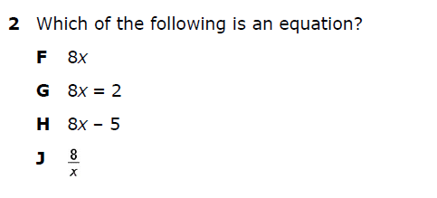

6.7B - 1 (S) U6 Ninety nine Z

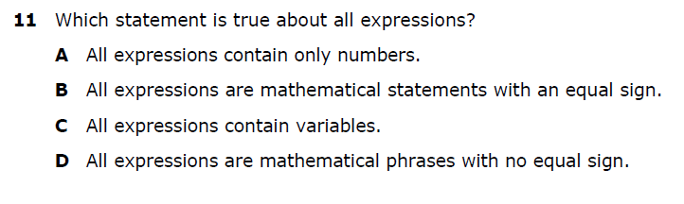

6.7C - 1 (S) One hundred Z
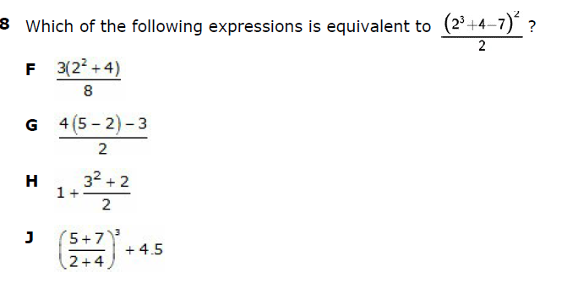

6.7C – 1 (S) One hundred one Y
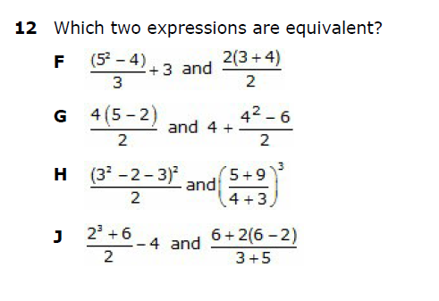

6.8B – 3 (S) One hundred eight Y
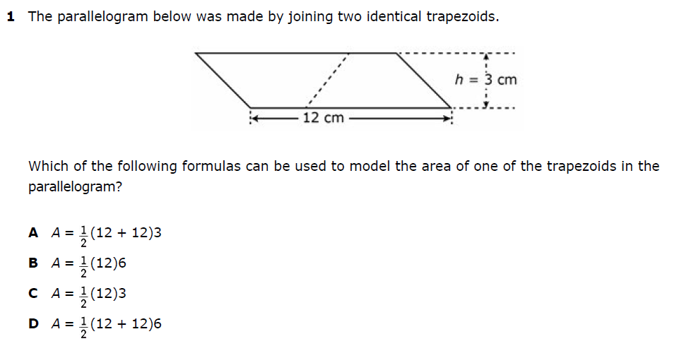

6.8B – 3 (S)
One hundred nine G
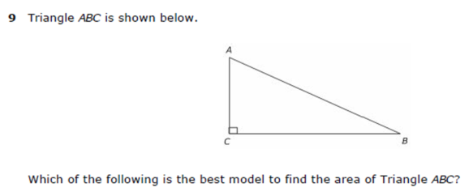
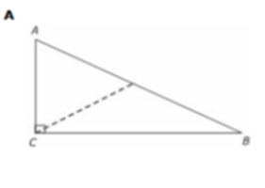

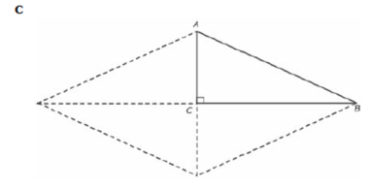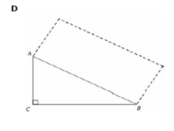

6.13B – 4 (S) One hundred sixty two X

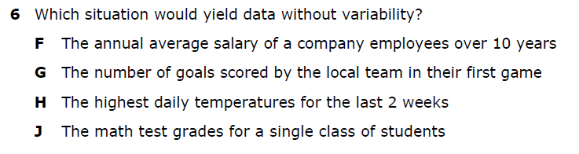

6.13B – 4 (S) One hundred sixty three Y

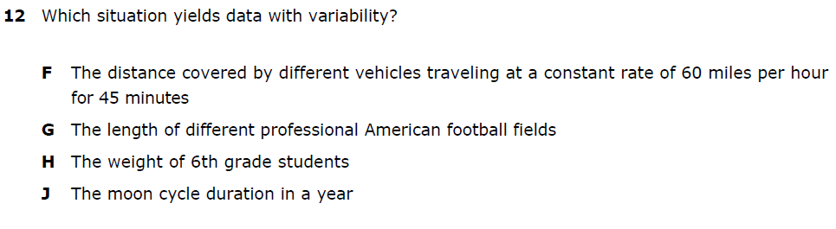

6.14A – 4 (S) One hundred sixty four W

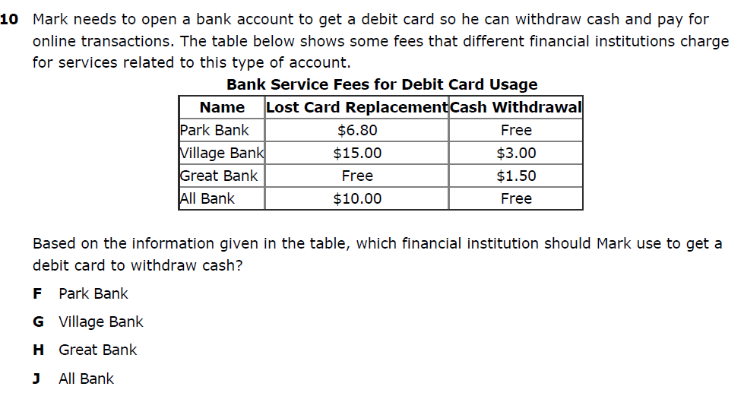

6.14A – 4 (S) One hundred sixty five X

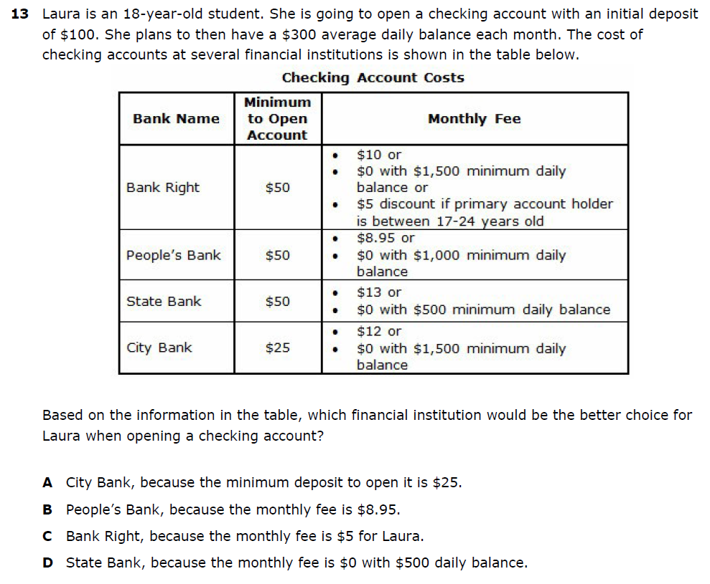
6.14F – 4 (S) One hundred seventy four Z

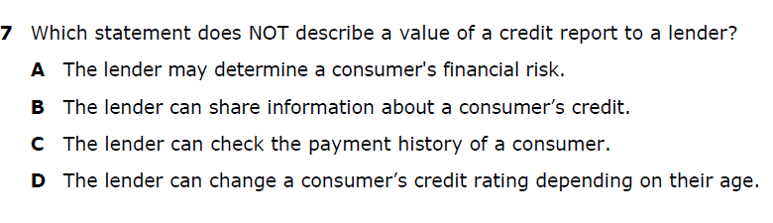

6.14F – 4 (S) One hundred seventy five X

